**KL University**



**Department of Computer ScienceEngineering**

**Course code -15CS2007**

**Database Systems**

**II B. Tech – 2nd Semester**

**Academic Year 2016-2017**

**Project Based Lab**

**ON**

**ART gallery (ARTg)**

**Section – S1**

**Batch No: 23**

|  |  |  |
| --- | --- | --- |
| Student ID | Student Name | Department |
| 150030722 | P.Sateesh | CSE |
| 150030991 | V.Lasya | CSE |

**K L University**

**DEPARTMENT OF COMPUTER SCIENCE ENGINEERING**

**(DST-FIST Sponsored Department)**



**CERTIFICATE**

This is to certify that the course based project entitled **“ART gallery ”** is a bonafide work done by **P.Sateesh (150030722), V. Lasya (150030991),** in partial fulfilment of the requirement for the award of degree in **BACHELOR OF TECHNOLOGY** in **Computer Science Engineering** during the academic year **2016-2017.**

**Faculty In Charge Head of the Department**

**Mr. Hari Kiran Vege Prof. Srikanth Vemuru**

**DEPARTMENT OF COMPUTER SCIENCE ENGINEERING**

**(DST-FIST Sponsored Department)**



**DECLARATION**

We hereby declare that this project based lab report entitled **“ARTg”** has been prepared by us in partial fulfillment of the requirement for the award of degree “**BACHELOR OF TECHNOLOGY in COMPUTER SCIENCE ENGINEERING**” during the academic year 2016-2017.

We also declare that this project based lab report is of our own effort and it has not been submitted to any other university for the award of any degree.

**Date:**

**Place: Vaddeswaram**

|  |  |
| --- | --- |
| **Name** | **Student ID** |
| **P. Sateesh** | **150030722** |
| **V. Lasya** | **150030991** |

# ACKNOWLEDGMENTS

It is great pleasure for me to express my gratitude to our honorable President **Sri. Koneru Satyanarayana**, for giving the opportunity and platform with facilities in accomplishing the project based laboratory report.

I express the sincere gratitude to our principal **Dr. A. Anand Kumar** for his administration towards our academic growth.

I express sincere gratitude to our Coordinator **Dr. A. Satya Kalyan** for his leadership and constant motivation provided in successful completion of our academic semester.

I record it as my privilege to deeply thank our pioneer **Dr. V. Srikanth**, HOD CSE Dept., for providing us the efficient faculty and facilities to make our ideas into reality.

I express my sincere thanks to our project supervisor­­­­ **Dr.V. Hari Kiran** for his novel association of ideas, encouragement, appreciation and intellectual zeal which motivated us to venture this project successfully.

Finally, it is pleased to acknowledge the indebtedness to all those who devoted themselves directly or indirectly to make this project report success.

**PROJECT ASSOCIATES**

|  |  |
| --- | --- |
| **Name** | **Student ID** |
| **P.Sateesh** | **150030722** |
| **V.Lasya** | **150030991** |

Table of Contents

Abstract 7

Introduction 8

PROJECT DESCRIPTION 9

List of Entities & Attributes 10

ER Diagram (Conceptual Model) 11

Schema Diagram 12

Normalization & Final List of Relations 13

Create & Insert SQL Queries 14

SQL Queries related to Report Generation 15

Conclusion 16

# Abstract

ARTG, which builds a product for the art galleries. The main aim of this is , a database with a schema that takes all the data that galleries must maintain. The galleries maintain the information about artists, their unique names, place of birth, age, and the style of art. For each piece of art, the artist, the year it was made, its unique title, its type of art (e.g., painting, lithograph, sculpture, photograph), and its price/cost must be stored. The pieces of art can also classified into groups like portraits, still lifes, works by Picasso and so on. An art may belong to more than one group. Each group is identified by a unique name which describes the group. The galleries also keep information about customers. For each customer, galleries keep that person’s unique name, address, total amount of money spent in the gallery and the artists and groups of art that the customer tends to like. Above all you can also become an art dealer. Moreover, you have to have a vision and everything you exhibit and offer for sale should explain that vision. Showing the consistency in the artwork is unique. The very old definition of art gallery is gone, most of the art galleries are unique and attractive. The best location for an art gallery is the best upscale business people who share their ideas. When it comes to buying an art, very few people do this. The people who are well educated and have great artistic thought, plain hearted and various other mentalities of people will go further to buy an art. There may be a variety of art galleries but don’t try to become there will be everything for everybody. Most of the times, the art maker has to open the gallery highlighting their own paintings and art. The American art and Spanish art play a vital role in the world of art galleries. The people will have to look forward to buy an art in the perspective of nature lover or maintain your own gallery in the perspective of manager.

# Introduction

  Database is an organized collection of data. The data is typically organized to model aspects of reality in a way that supports processes requiring information. A DBMS makes it possible for end users to create, read, update and delete data in a database. The DBMS essentially serves as an interface between the database and end users or application programs, ensuring that data is consistently organized and remains easily accessible. The DBMS manages three important things: the data, the database engine that allows data to be accessed, locked and modified and the database schema, which defines the database’s logical structure. These three foundational elements help provide concurrency, security, data integrity and uniform administration procedures. The DBMS can offer both logical and physical data independence. That means it can protect users and applications from needing to know where data is stored or having to be concerned about changes to the physical structure of data.

The main aim of this is, a database with a schema that takes all the data that galleries must maintain. The galleries maintain the information about artists, their unique names, place of birth, age, and the style of art. For each piece of art, the artist, the year it was made, its unique title, its type of art (e.g., painting, lithograph, sculpture, photograph), and its price/cost must be stored. The pieces of art can also classified into groups like portraits, still lifes, works by Picasso and so on. An art may belong to more than one group. Each group is identified by a unique name which describes the group. The galleries also keep information about customers. For each customer, galleries keep that person’s unique name, address, total amount of money spent in the gallery and the artists and groups of art that the customer tends to like. Above all you can also become an art dealer. Moreover, you have to have a vision and everything you exhibit and offer for sale should explain that vision. Showing the consistency in the artwork is unique. The very old definition of art gallery is gone, most of the art galleries are unique and attractive.

# PROJECT DESCRIPTION

If you want to become an artist, you can end with some databases where you just staring at them. But if you maintain your own database, you can see all your mates at one place. So, you establish a database company, ARTG, which builds a product for the art galleries. The main aim of this is, a database with a schema that takes all the data that galleries must maintain. The galleries maintain the information about artists, their unique names, place of birth, age, and the style of art. For each piece of art, the artist, the year it was made, its unique title, its type of art (e.g., painting, lithograph, sculpture, photograph), and its price/cost must be stored. The pieces of art can also classified into groups like portraits, still lifes, works by Picasso and so on. An art may belong to more than one group. Each group is identified by a unique name which describes the group. The galleries also keep information about customers. For each customer, galleries keep that person’s unique name, address, total amount of money spent in the gallery and the artists and groups of art that the customer tends to like. Above all you can also become an art dealer. Moreover, you have to have a vision and everything you exhibit and offer for sale should explain that vision. Showing the consistency in the artwork is unique. The very old definition of art gallery is gone, most of the art galleries are unique and attractive. The best location for an art gallery is the best upscale business people who share their ideas. When it comes to buying an art, very few people do this. The people who are well educated and have great artistic thought, plain hearted and various other mentalities of people will go further to buy an art. There may be a variety of art galleries but don’t try to become there will be everything for everybody. Most of the times, the art maker has to open the gallery highlighting their own paintings and art. The American art and Spanish art play a vital role in the world of art galleries. The people will have to look forward to buy an art in the perspective of nature lover or maintain your own gallery in the perspective of manager.

# List of Entities & Attributes

|  |  |
| --- | --- |
| **ENTITIES** | **ATTRIBUTES** |
| GALLERY | g_id ,g_name,g_address |
| EMPLOYEE | emp_id, emp_name ,emp_address,emp_join_date |
| ARTIST | Artist_id,artist_name,place_of_birth,style_of_art |
| ART | Art_id,unique_title,year_it_was_made,type_of_art,artist_id |
| OFFER | Offer_id,offer_name |
| CUSTOMER | Customer_id,customer_name,customer_address |
| GROUP | Group_id,group_name |

**RELATIONSHIPS:**

**Maintains** relationship between GALLERY and ART

**🡪**Gallery maintains arts

**Classified** relationship between GROUP and ART

🡪Art is classified into groups

**Manages** relationship between EMPLOYEE and GALLERY

🡪Manager manages the GALLERY

**WORKS** relationship between EMPLOYEE and GALLERY

🡪Employee works in GALLERY

**PLACES** relationship between GALLERY and OFFER

🡪Gallery places offer

**CONTAINS** relationship between GALLERY and CUSTOMER

🡪Each gallery contains customers

**DEALER** relationship between ARTIST and DEALER

🡪An artist can behave as a dealer

**BUY** relationship between GALLERY,CUSTOMER and ART

🡪Customers buys an art in registered gallery

**LIKES** relationship between ARTIST and CUSTOMER

🡪Customer can list have favourite artists.

**LIKES1**  relationship between ARTIST and GROUP_S

🡪Customer can list have favourite groups.

# ER Diagram (Conceptual Model)

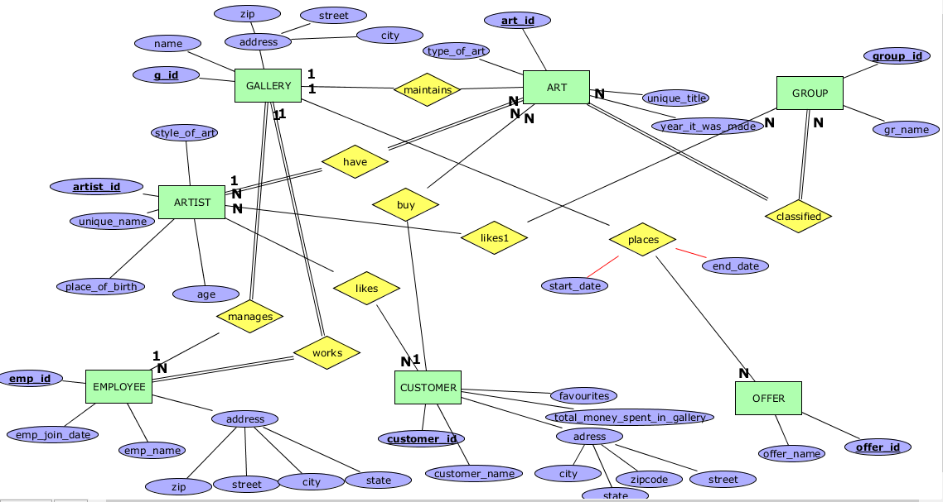

# Schema Diagram

GALLERY

|  |  |  |  |  |
| --- | --- | --- | --- | --- |
| **g_id** | g_name | g_city | manager_id | g_pin |

EMPLOYEE

|  |  |  |  |  |  |  |  |
| --- | --- | --- | --- | --- | --- | --- | --- |
| **emp_id** | emp_name | emp-join_date | g_id | emp_zip | emp_city | Emp_street | Emp_state |

ARTIST

|  |  |  |  |
| --- | --- | --- | --- |
| **artist_id** | artist_name | place_of_birth | style_of_art |

ART

|  |  |  |  |  |
| --- | --- | --- | --- | --- |
| **art_id** | unique_title | year_it_was_made | type_of_art | artist_id |

CUSTOMER

|  |  |  |  |  |  |
| --- | --- | --- | --- | --- | --- |
| **customer_id** | customer_name | Cus_zip | Cus_city | Cus_street | Cus_state |

GROUP_S

|  |  |
| --- | --- |
| **group_id** | group_name |

MAINTAINS

|  |  |
| --- | --- |
| **g_id** | **art_id** |

CLASSIFIED

|  |  |
| --- | --- |
| art_id | **group_id** |

OFFER

|  |  |
| --- | --- |
| offer_id | Vision |

PLACE

|  |  |
| --- | --- |
| **g_id** | **offer_id** |

CONTAINS

|  |  |
| --- | --- |
| **g_id** | **customer_id** |

DEALER

|  |  |
| --- | --- |
| **artist_id** | **dealer_id** |

BUY

|  |  |  |  |
| --- | --- | --- | --- |
| **customer_id** | **art_id** | date | Price |

LIKES

|  |  |
| --- | --- |
| **customer_id** | **artist_id** |

LIKES1

|  |  |
| --- | --- |
| **customer_id** | **group_id** |

# Normalization & Final List of Relations

By applying normalization to above schema we get the tables in 3NF.The final list of Relations are shown below.

GALLERY

|  |  |  |  |  |
| --- | --- | --- | --- | --- |
| **g_id** | g_name | g_city | manager_id | g_pin |

EMPLOYEE

|  |  |  |  |
| --- | --- | --- | --- |
| **emp_id** | emp_name | Emp_join_date | g_id |

ADDRESS_TYPE

|  |  |
| --- | --- |
| **addr_id** | addr_type |

ZIP

|  |  |  |  |
| --- | --- | --- | --- |
| **Zipcode** | city | state | country |

EMP_ADDR

|  |  |  |  |
| --- | --- | --- | --- |
| **emp_id** | **addr_id** | street | Zipcode |

ARTIST

|  |  |  |  |
| --- | --- | --- | --- |
| **artist_id** | artist_name | place_of_birth | style_of_art |

ART

|  |  |  |  |  |  |  |  |
| --- | --- | --- | --- | --- | --- | --- | --- |
| **art_id** | unique_title | year_it_was_made | type_of_art | artist_id | height | width | Material |

CUSTOMER

|  |  |
| --- | --- |
| **customer_id** | customer_name |

CUS_ADDR

|  |  |  |  |
| --- | --- | --- | --- |
| **cus_id** | **addr_id** | street | Zipcode |

GROUP_S

|  |  |
| --- | --- |
| **group_id** | group_name |

MAINTAINS

|  |  |
| --- | --- |
| **g_id** | **art_id** |

CLASSIFIED

|  |  |
| --- | --- |
| **Art_id** | **group_id** |

OFFER

|  |  |  |  |  |
| --- | --- | --- | --- | --- |
| **offer_id** | Offer_name | Start_date | End_date | vision |

PLACE

|  |  |
| --- | --- |
| **g_id** | **offer_id** |

CONTAINS

|  |  |
| --- | --- |
| **g_id** | **customer_id** |

DEALER

|  |  |
| --- | --- |
| **artist_id** | **dealer_id** |

BUY

|  |  |  |  |
| --- | --- | --- | --- |
| **customer_id** | **art_id** | date | Price |

LIKES

|  |  |
| --- | --- |
| **customer_id** | **artist_id** |

LIKES1

|  |  |
| --- | --- |
| **customer_id** | **group_id** |

# **Create & Insert** SQL **Queries**

**CREATION OF TABLES**

**CREATION OF EMPLOYEE TABLE**

create table if not exists employee(

emp_id int primary key,

emp_name char(50),

emp_join_date date);

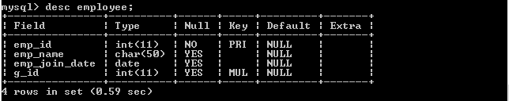

**CREATION OF GALLERY TABLE**

create table if not exists gallery(

g_id int primary key,

g_name char(50),

g_city char(20),

manager_id int;

constraint fk FOREIGN KEY(manager_id)REFERENCES employee(emp_id));

create table if not exists address_type(

addr_id int primary key,

addr_type char(20));

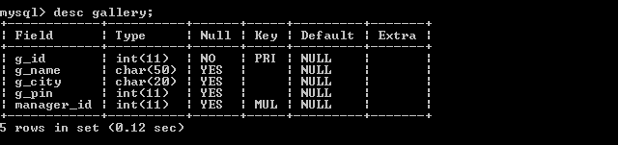

**CREATION OF ZIP TABLE**

create table if not exists zip(

zipcode int primary key,

city char(30),

state char(20),

country char(20));

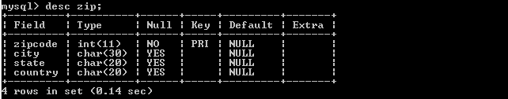

**CREATION OF ADDR_TYPE TABLE**

create table if not exists address_type(

addr_id int primary key,

addr_type char(20));

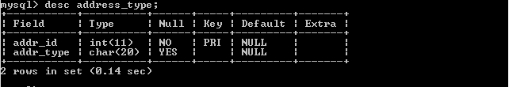

**CREATION OF EMP_ADDR TABLE**

create table if not exists emp_addr(

emp_id int,

addr_id int,

street char(100),

zipcode int,

constraint ei_fk FOREIGN KEY(emp_id) REFERENCES employee(emp_id),

constraint ai_fk FOREIGN KEY(addr_id) REFERENCES address_type(addr_id),

constraint zi_fk FOREIGN KEY(zipcode)REFERENCES zip(zipcode),

primary key(emp_id,addr_id));

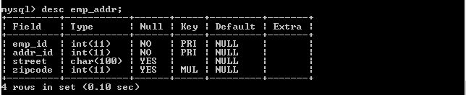

**CREATION OF ARTIST TABLE**

create table if not exists artist(

artist_id int primary key,

artist_name char(50),

place_of_birth char(50),

style_of_art char(20));

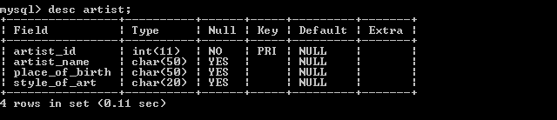

**CREATION OF ART TABLE**

create table if not exists art(

art_id int primary key,

unique_title char(50),

year_it_was_made year,

type_of_art char(20),

height int,

width int,

material char(20),

artist_id int,

constraint ar_fk FOREIGN KEY(artist_id) REFERENCES artist(artist_id));

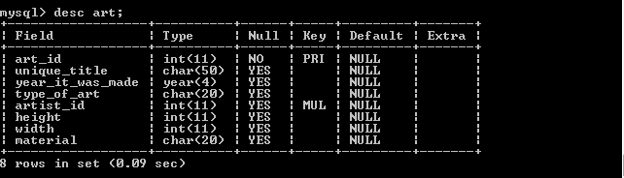

**CREATION OF CUSTOMER TABLE**

create table if not exists customer(

customer_id int primary key,

customer_name char(50));

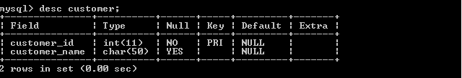

**CREATION OF CUSTOMER _ADDR TABLE**

create table if not exists cus_addr(

customer_id int,

addr_id int,

street char(100),

zipcode int,

constraint mi_fk FOREIGN KEY(customer_id) REFERENCES customer(customer_id),

constraint bi_fk FOREIGN KEY(addr_id) REFERENCES address_type(addr_id),

constraint ci_fk FOREIGN KEY(zipcode)REFERENCES zip(zipcode),

primary key(customer_id,addr_id));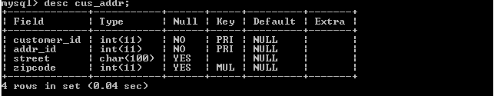

**CREATION OF GROUP_S TABLE**

create table if not exists group_s(

group_id int primary key,

group_name char(20));

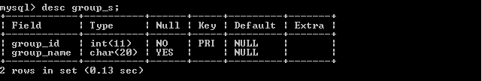

**CREATION OF MAINTAINS TABLE**

create table if not exists maintains(

g_id int,

art_id int,

constraint g_fk FOREIGN KEY(g_id) REFERENCES gallery(g_id),

constraint ak_fk FOREIGN KEY(art_id) REFERENCES art(art_id),

primary key(g_id,art_id));

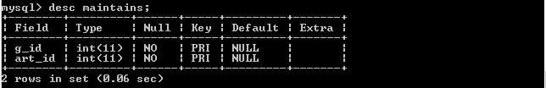

**CREATION OF CLASSIFIED TABLE**

create table if not exists classified(

art_id int,

group_id int,

constraint a_fk FOREIGN KEY(art_id) REFERENCES art(art_id),

constraint r_fk FOREIGN KEY(group_id) REFERENCES group_s(group_id),

primary key(art_id,group_id));

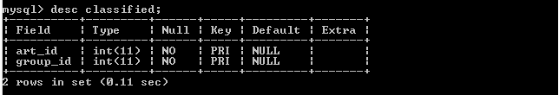

**CREATION OF OFFER TABLE**

create table if not exists offer(

offer_id int primary key,

vision char(20)

start_date date

end_date date);

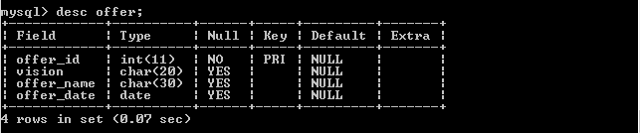

**CREATION OF PLACE TABLE**

create table if not exists place(

g_id int,

offer_id int,

constraint gr_fk FOREIGN KEY(g_id) REFERENCES gallery(g_id),

constraint or_fk FOREIGN KEY(offer_id) REFERENCES offer(offer_id),

primary key(g_id,offer_id));

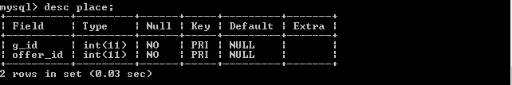

**CREATION OF CONTAINS TABLE**

create table if not exists contains(

g_id int,

customer_id int,

constraint gl_fk FOREIGN KEY(g_id) REFERENCES gallery(g_id),

constraint cr_fk FOREIGN KEY(customer_id) REFERENCES customer(customer_id),

primary key(g_id,customer_id));

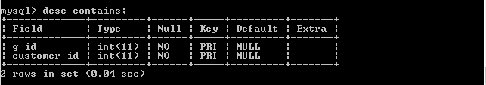

**CREATION OF DEALER TABLE**

create table if not exists dealer(

artist_id int,

dealer_id int,

constraint at_fk FOREIGN KEY(artist_id) REFERENCES artist(artist_id),

constraint dr_fk FOREIGN KEY(dealer_id) REFERENCES artist(artist_id),

primary key(artist_id,dealer_id));

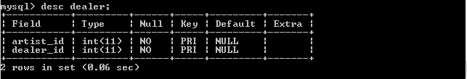

**CREATION OF BUY TABLE**

create table if not exists buy(

customer_id int,

art_id int,

date date,

price int

constraint crr_fk FOREIGN KEY(customer_id) REFERENCES customer(customer_id),

constraint az_fk FOREIGN KEY(art_id) REFERENCES art(art_id),

primary key(customer_id,art_id));

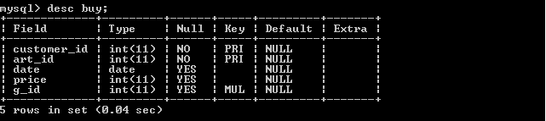

**CREATION OF LIKES TABLE**

create table if not exists likes(

customer_id int,

artist_id int,

constraint ax_fk FOREIGN KEY(artist_id) REFERENCES artist(artist_id),

constraint cz_fk FOREIGN KEY(customer_id) REFERENCES customer(customer_id),

primary key(customer_id,artist_id));

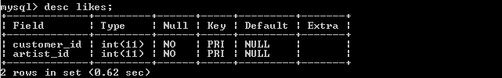

**CREATION OF LIKES1 TABLE**

create table if not exists likes1(

customer_id int,

group_id int,

constraint gy_fk FOREIGN KEY(group_id) REFERENCES group_s(group_id),

constraint cy_fk FOREIGN KEY(customer_id) REFERENCES customer(customer_id),

primary key(customer_id,group_id));

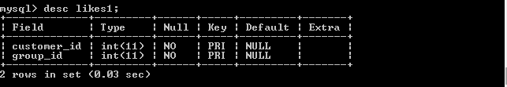

**CREATION OF ALL TABLES**

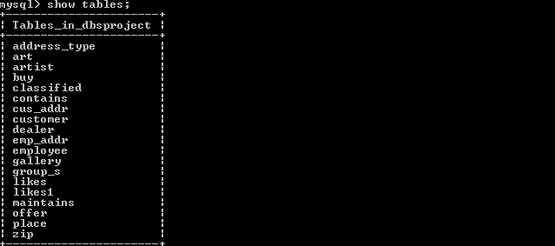

**INSERTION OF TABLES**

**INSERTION INTO EMPLOYEE TABLE**

insert into employee(emp_id,emp_name,emp_join_date,g_id)values

(700,'Arjun','2007-11-13',1),(701,'venkat','2006-08-11',1),(702,'vamsi','2000-06-23',1),

(800,'Anvesh','2012-07-04',2),(801,'hemanth','2005-04-11',2),(802,'kishore','2003-09-19',2),

(900,'Ankith','2008-05-03',3),(901,'Rahul','2006-05-12',3),(902,'manoj','2002-06-14',3),

(600,'shashank','2014-03-03',4),(601,'Arun','2013-09-12',4),(602,'Gopal','2012-01-01',4);

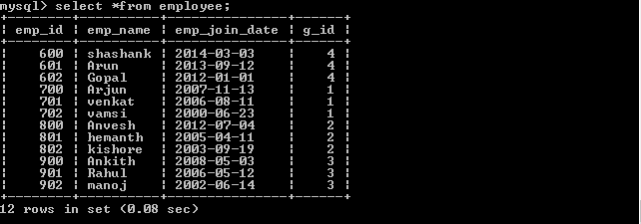

**INSERTION INTO GALLERY TABLE**

insert into gallery(g_id,g_name,g_city,g_pin,manager_id)values

(1,'Young_blood_art_studio','vijayawada',520001,700),(2,'Byrne','guntur',522007,800),

(3,'Dairy Barn','vizag',530016,900),(4,'Redfox','Hyderabad',500001,600);

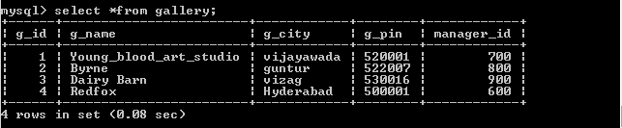

**INSERTION INTO ZIP TABLE**

insert into zip(zipcode,city,state)values(522007,'Guntur','Andhra

Pradesh'),(530016,'vizag','Andhra Pradesh'),(520001,'vijayawada','Andhra

Pradesh'),(500001,'hyderabad','Telangana');

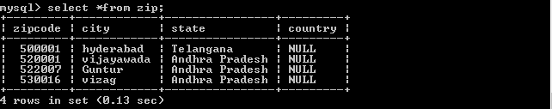

**INSERTION INTO ADDR_TYPE TABLE**

insert into address_type(addr_id,addr_type)values(1,'Residential'),

(2,'Office'),(3,'Delivery');

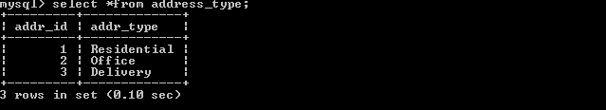

**INSERTION INTO EMP_ADDR TABLE**

insert into emp_addr(emp_id,addr_id,street,zipcode)values

(700,1,'Gandhinagar street',522007),(700,2,'red cross street',522007),

(600,1,'churchil',530016),(601,2,'Srinagar',530016),(800,1,'gardens

street',500001),(800,2,'shopping street',520001);

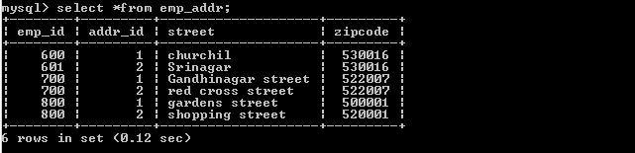

**INSERTION INTO ARTIST TABLE**

insert into artist(artist_id,artist_name,place_of_birth,style_of_art)values

(11,'sateesh','guntur','Abstract_expression'),(12,'saikrishna','vijayawada','Conceptual art'),

(13,'srinu','hyderabad','Proto-Cubism'),(14,'Bhargav','vizag','Constructivism');

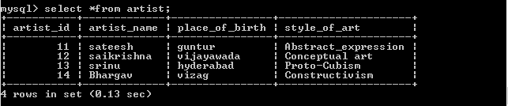

**INSERTION INTO ART TABLE**

insert into art(art_id,unique_title,year_it_was_made,type_of_art,artist_id)values

(111,'glory',2001,'painting',11),(112,'sacrifice',2000,'photograph',12),

(113,'respect',1990,'lithograph',13),(114,'dominance',1999,'painting',14),

(115,'Happiness',2009,'painting',14), (116,'The Persistence of Memory',2000,'painting',12),(117,'Drowning Girl',2010,'painting',11);

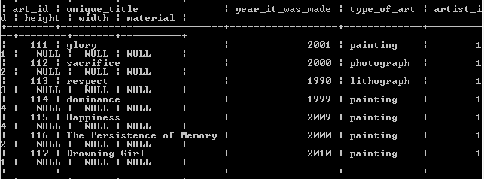

**INSERTION INTO GROUP_S TABLE**

insert into group_s(group_id,group_name)values(1111,'potrait'),

(1112,'still_files'),(1113,'works_by_picasso');

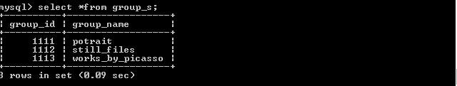

**INSERT ION INTO OFFER TABLE**

insert into offer(offer_id,offer_name,offer_date)values(11122,'skill

exhibition','2012-10-01'),(11133,'photo exhibtion','2013-11-01');

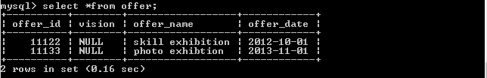

**INSERTION INTO CUSTOMER TABLE**

insert into customer(customer_id,customer_name)values(100,'sekhar'),

(200,'ashok'),(300,'pavan'),(301,'Akhil'),(302,'Sriman'),(303,'Bharath'),

(304,'Sriteja'),(305,'varun'),(306,'venkatesh');

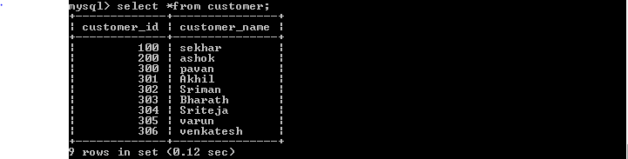

**INSERTION INTO CUS_ADDR TABLE**

insert into cus_addr(customer_id,addr_id,street,zipcode)values

(100,1,'Gandhinagar street',522007),(200,2,'red cross street',522007),

(300,1,'churchil',530016),(301,2,'Srinagar',530016),(302,1,'gardens

street',500001),(303,2,'shopping street',520001);

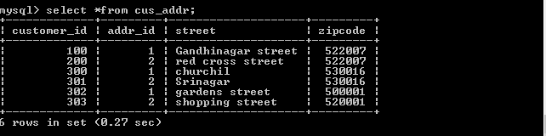

**INSERTION INTO MAINTAINS TABLE**

insert into maintains(g_id,art_id)values(1,111),(1,112),(2,113),(3,114),

(4,115),(1,116),(2,117);

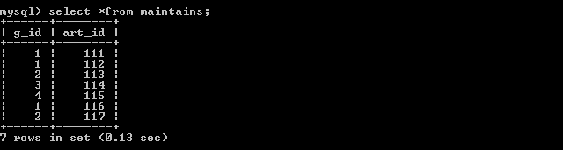

**INSERTION INTO CLASSIFIED TABLE**

insert into classified(art_id,group_id)values(111,1111),(112,1112),

(113,1111),(114,1113),(115,1112);

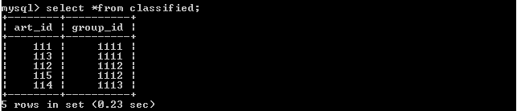

**INSERTION INTO PLACE TABLE**

insert into place(g_id,offer_id)values(1,11122),(2,11122),(3,11133);

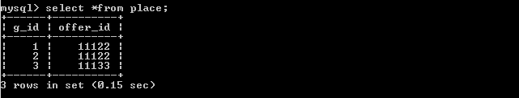

**INSERTION INTO CONTAINS TABLE**

insert into contains(g_id,customer_id)values(1,100),(2,200),(1,200),

(2,100),(3,300),(4,100),(2,301),(3,302),(4,303);

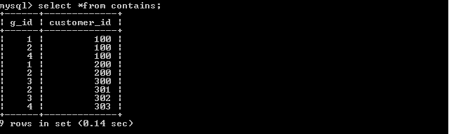

**INSERTION INTO DEALER TABLE**

insert into dealer(artist_id,dealer_id)values(11,11),(12,11),(13,13),

(14,13);

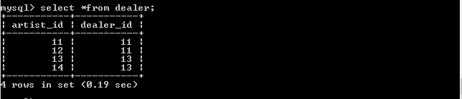

**INSERTION INTO BUY TABLE**

insert into buy(customer_id,art_id,date,price,g_id)values(100,111,'2011-06-01',10000,1),

(300,114,'2014-04-16',100000,3),(301,113,'1998-10-01',100055,2),(303,115,'2000-01-02',200000,4);

(100,116,'2000-02-04',100000,1),(301,117,'2002-04-03',150000,2);

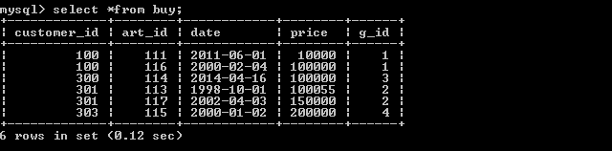

**INSERTION INTO LIKES TABLE**

insert into likes(customer_id,artist_id)values(100,11),(100,12),(300,13),

(300,14),(301,12),(303,14);

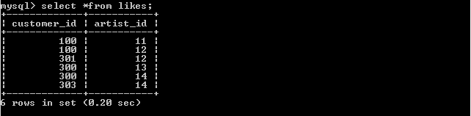

**INSERTION INTO LIKES1 TABLE**

Insert into likes1(customer_id,group_id)values(100,1111),(200,1112),(300,1111),(301,1113),(302,1112),(303,1111);

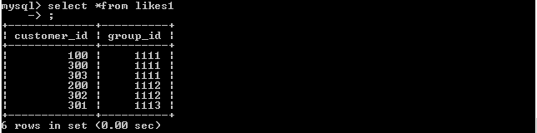

# SQL Queries related to Report Generation

/////////////////////////////////**Query to list customer at each gallery_id**////////////////////////////////////////////

1. select g.g_id,c.customer_id

from gallery g inner join customer c inner join contains m on m.customer_id=c.customer_id and m.g_id=g.g_id

order by g_id asc;

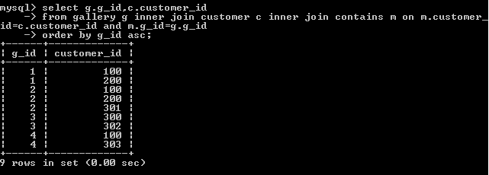

///////////////////////**Query to list residential address details of all the employees**//////////////////////////////

1. select m.emp_id,e.street,z.city,z.state

from emp_addr e inner join address_type a inner join employee m inner join zip z on z.zipcode=e.zipcode and e.emp_id=m.emp_id and e.addr_id=a.addr_id

order by emp_id asc;

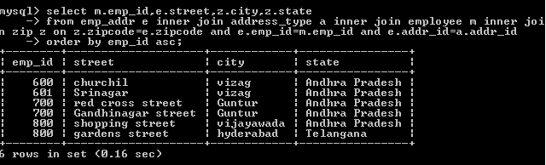

////////////////////////////////////////////Query to list the customer buyed arts///////////////////////////////////////

1. select customer_id,g_id,sum(price) as "total money spent by customer in gallery"

from buy

group by g_id;

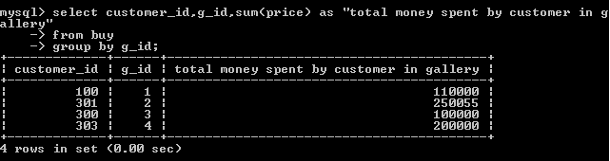

/////////Query to list the names of the artists and titles of arts of customer owned arts////////////

4.select c.customer_id,a.artist_id,a.unique_title

from buy b inner join customer c inner join art a inner join artist a1

on c.customer_id=b.customer_id and b.art_id=a.art_id and a.artist_id=a1.artist_id;

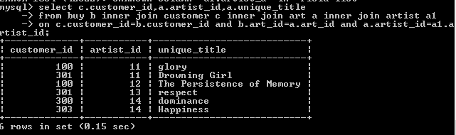

///////////////////////////Query to list the manager name and manager_id of each gallery/////////////////////

5.select emp_id as "manager_id",emp_name as "manager_name",g.g_id,emp_join_date

from employee e inner join gallery g on e.g_id=g.g_id

group by g_id;

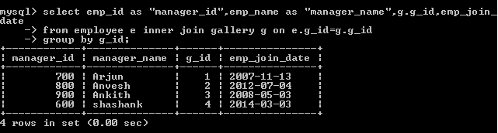

//////////Query to list the number of arts belongs to of each group and their names/////////

6.select g.group_name,count(g.group_id) as "number of arts for each group"

from classified c inner join art a inner join group_s g on c.art_id=a.art_id and g.group_id=c.group_id

group by g.group_id;

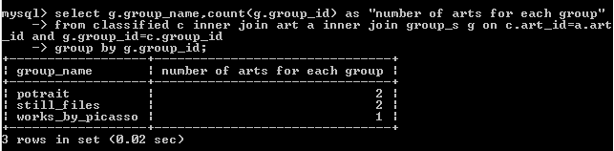

//////////////////////////////Query to list the details employees works for Dairy Barn gallery/////////////////

7.select e.emp_id,e.emp_name,g.g_id

from employee e inner join gallery g on e.g_id=g.g_id

where g_name='Dairy Barn';

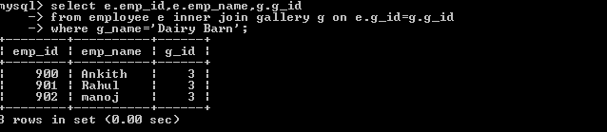

////////////////Query to list style of arts of all artists///////////

8.select style_of_art,artist_id,artist_name

from artist ;

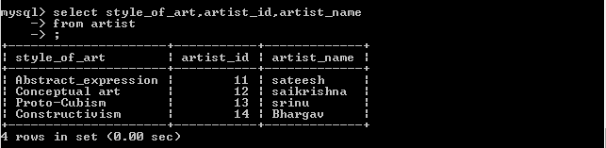

//////////////////////////////////Query to list the arts belongs to each gallery//////////////////////////////////////////

9. select g.g_id as "gallery_id" ,a.art_id

from maintains m inner join gallery g inner join art a on m.g_id=g.g_id and m.art_id=a.art_id

order by g.g_id asc;

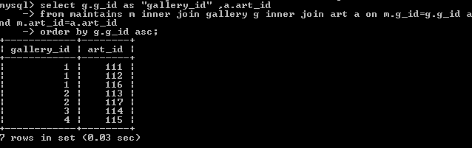

/////////////////////////Query to list the customer names of Young_blood_art_studio/////////////////////

10.select c.customer_id,c2.customer_name

from contains c inner join customer c2 inner join gallery g on c.customer_id=c2.customer_id and g.g_id=c.g_id

where g_name="Young_blood_art_studio";

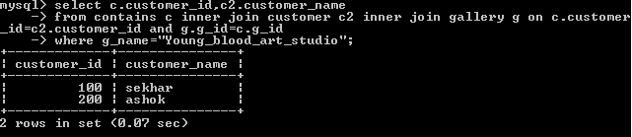

# Conclusion

Through painting, the artist expresses ideas and emotions, as well as a version of the reality he or she perceives, in a two-dimensional visual form

In this project we created database of different galleries which maintains the details of artists ,arts and customers and every realtions between them.

The data can be retrieved easily from the database among the relations in such a way we designed our database. It contains every information that held in gallery and the details of person involved in gallery.

We made creation, insertion and successfully executed many DML and DDL queries and normalized the schema into 3NF to reduce redundancy.

Finally, we conclude that ARTg is database which stores the details of each gallery and their employees and customer which makes easy of access to the employees and customers.